4TH QUESTION IS SIMULATED USING LTSPICE SIMULATION PROGRAM

First, we draw the circuit, and import the models as requested in the question.



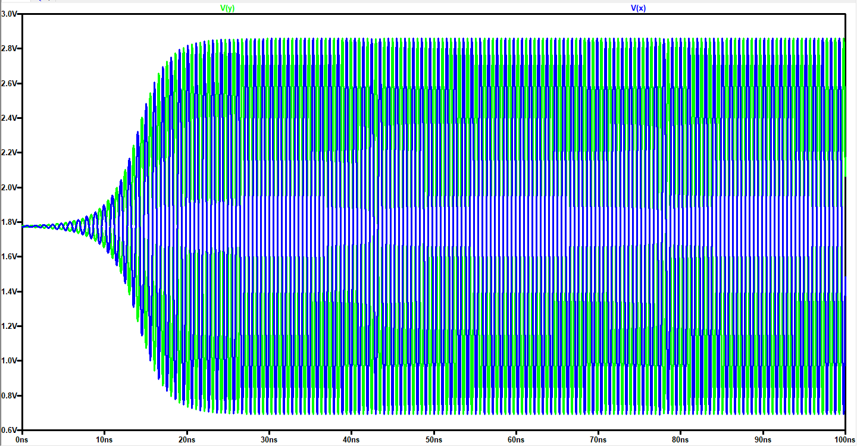Then, since we are looking for the 1GHZ of oscillation frequency, we should find a period of 1ns. Therefore, we are starting to record the data points by the .tran 0 200n 100n transient analysis command because it requires some time for the circuit to reach the steady-state. I thought 100ns will be adequate.

As it can be seen above that, 100ns of time is required for the circuit to start to oscillate.

Since I want to measure the time between two peak points of the sinusoidal waveform, I have to zoom in an area that I can easily show the time between two peaks.

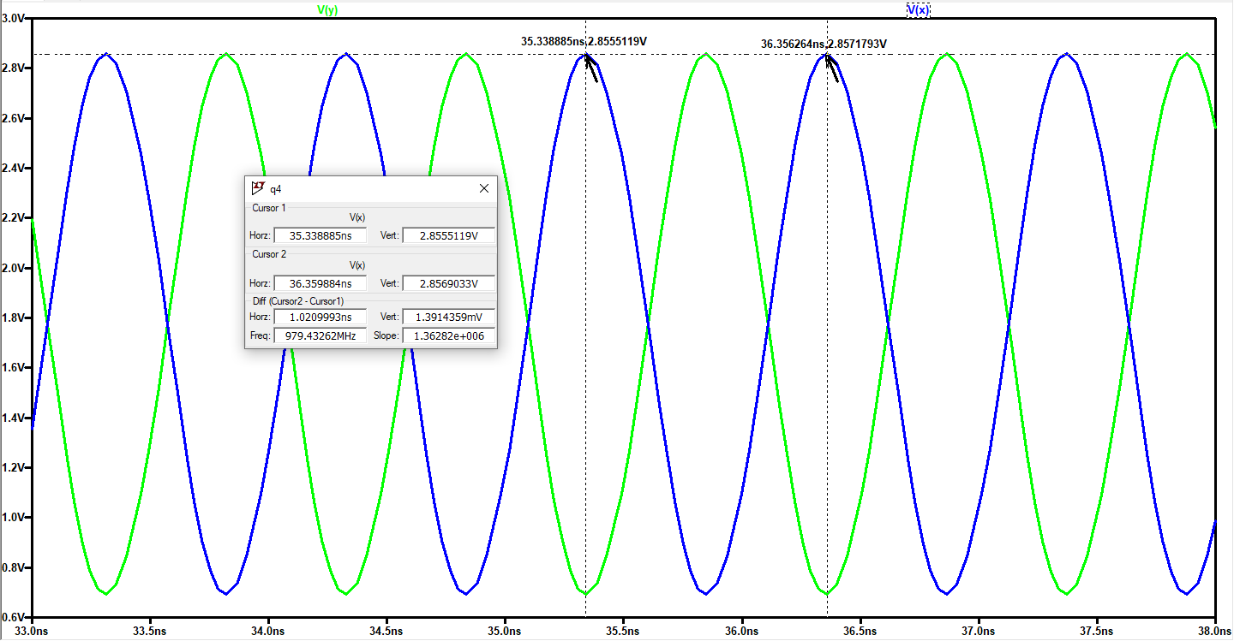

As it can be seen from the cursors, the time between two peaks of the sinusoid is approximately 1ns, which is corresponding to 1GHZ of oscillation frequency. Namely, for a capacitor value of 2.47 pF, we get a 1 GHZ of oscillation frequency.

Drain currents of M1 and M2 can be seen from the figure:

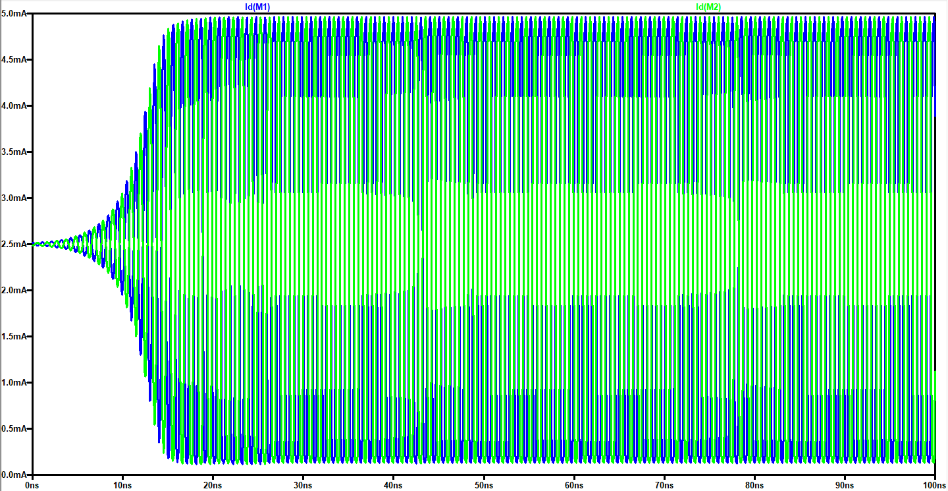

If we zoom in an area to see the steady state sinusoidal, we see these waveforms as shown

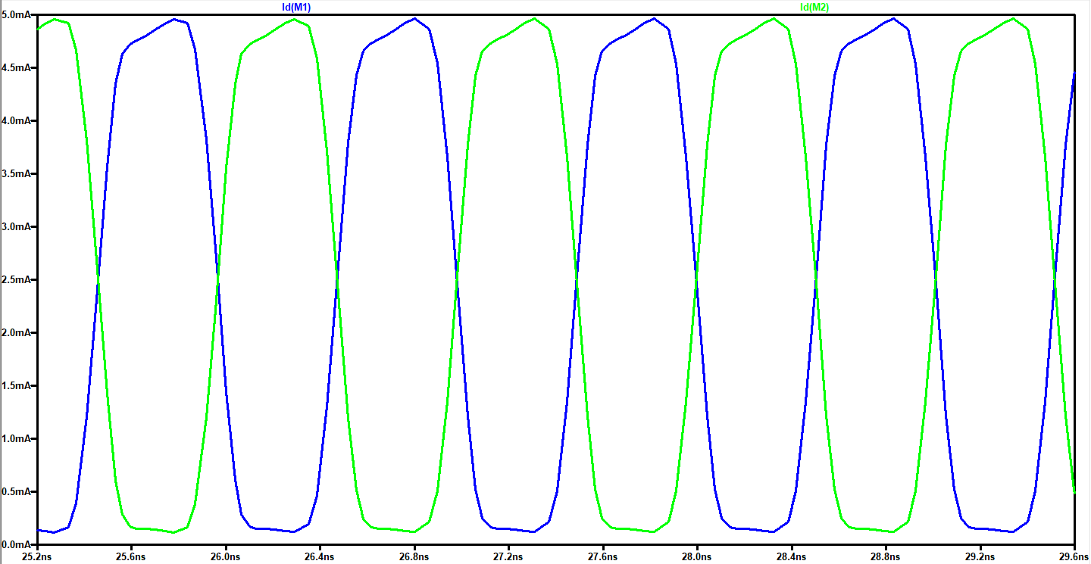

Now, let’s investigate the tail current value that ceases the oscillation. In order to find this value, we decrease the value of Iss by small steps until we don’t get an oscillation at the output.

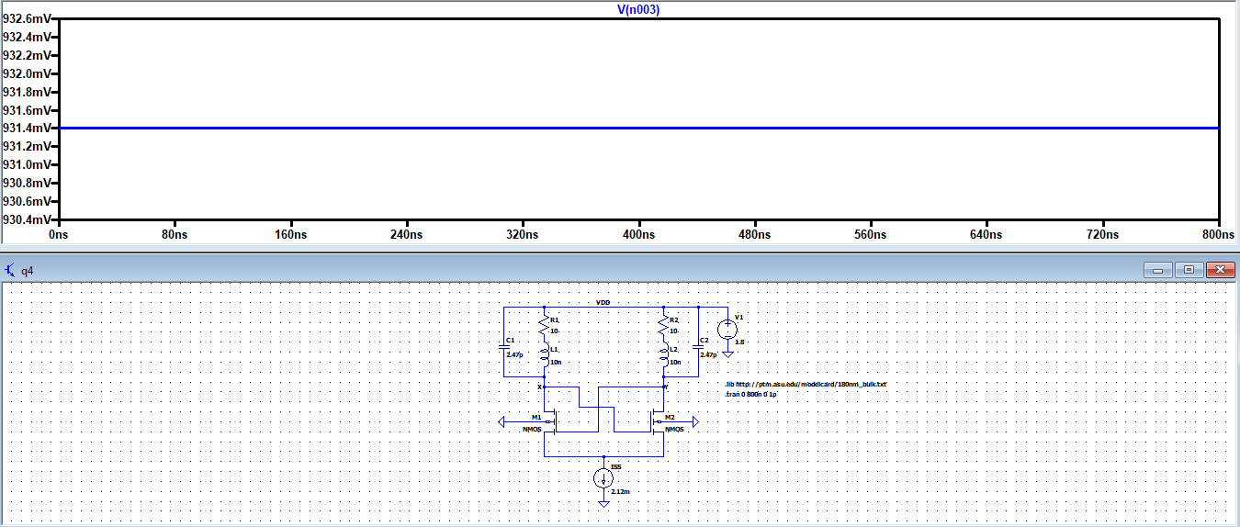For Iss = 2.12 mA, the output still oscillates but for the values lower than 2.12 mA, oscillation ceases.